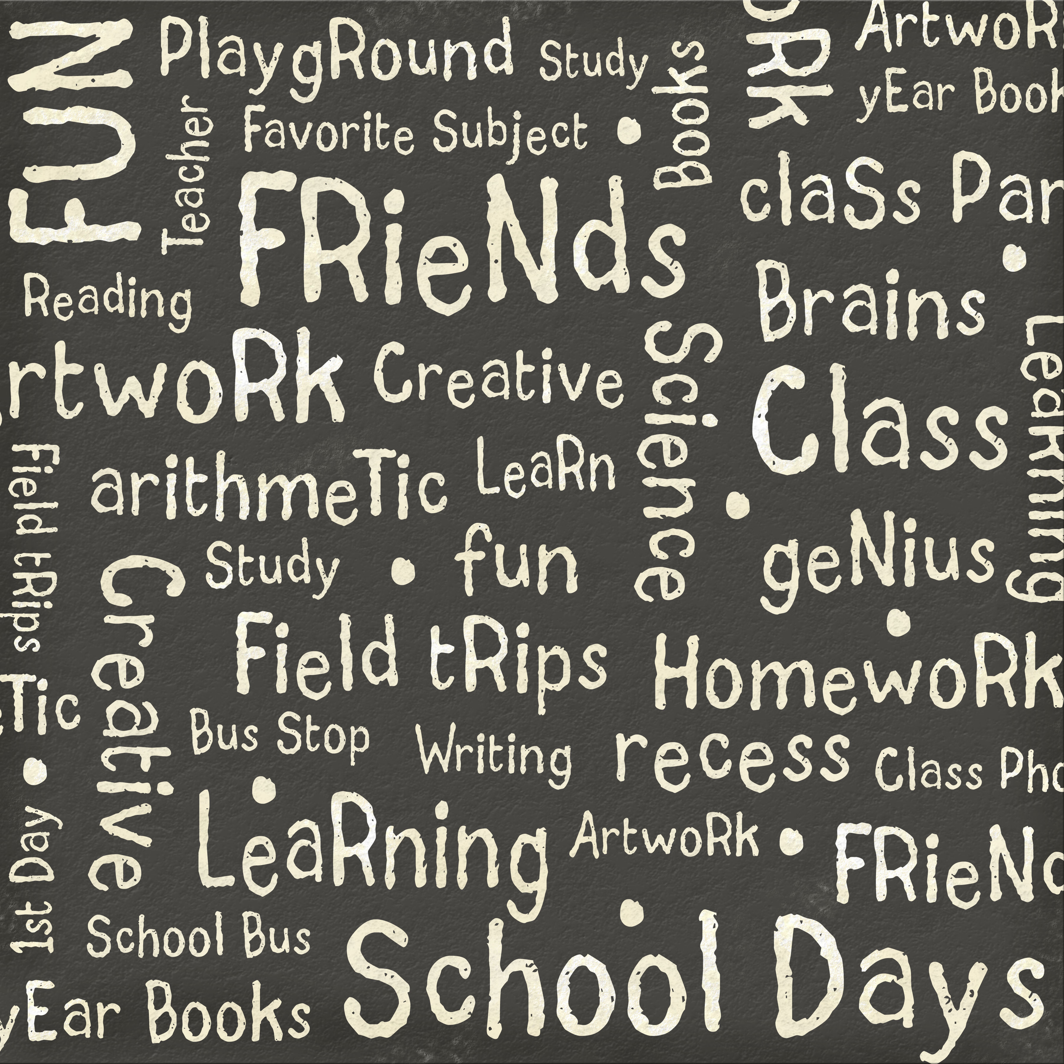
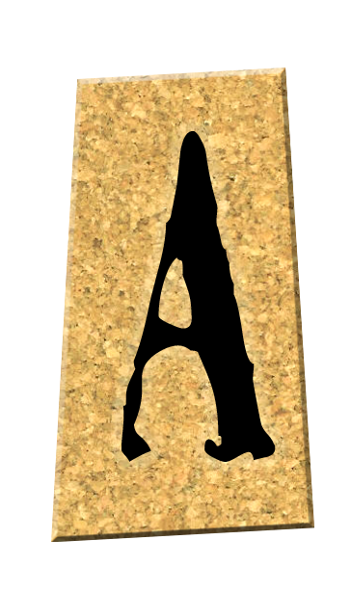
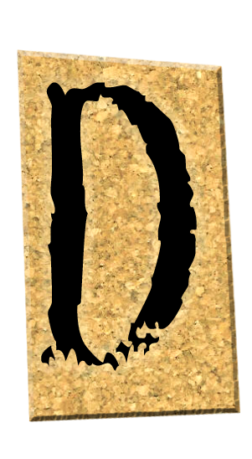
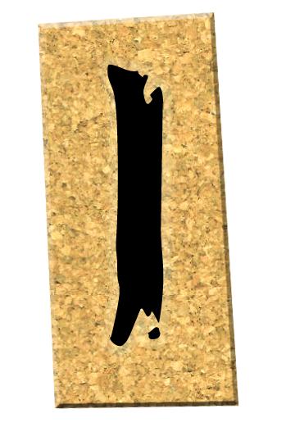
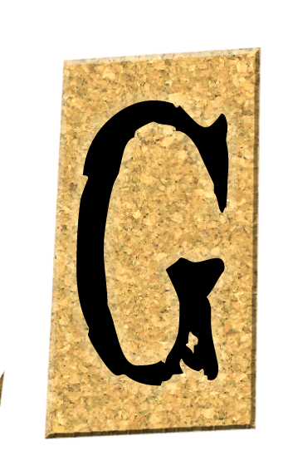
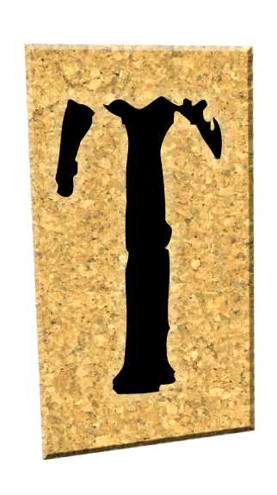
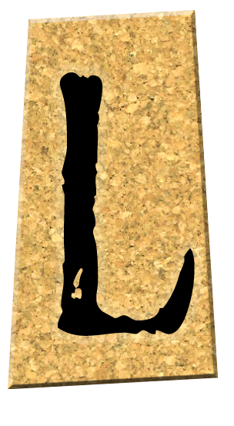
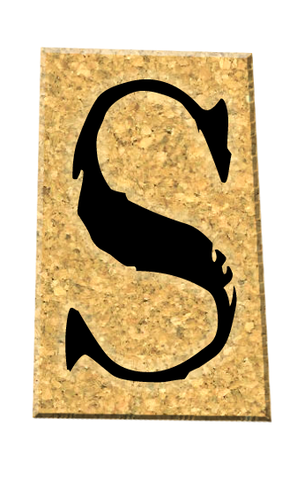


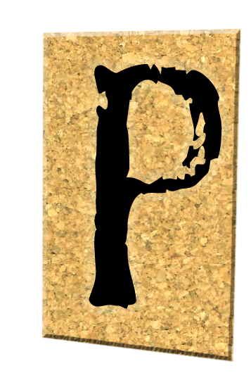
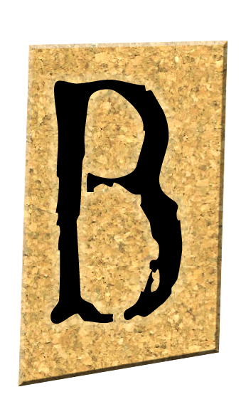
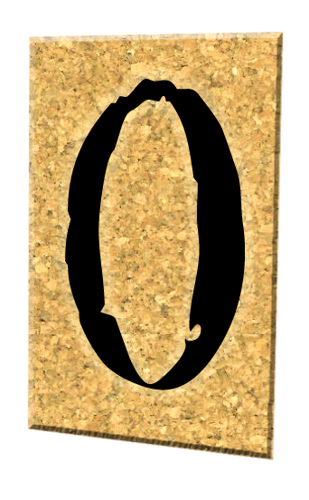
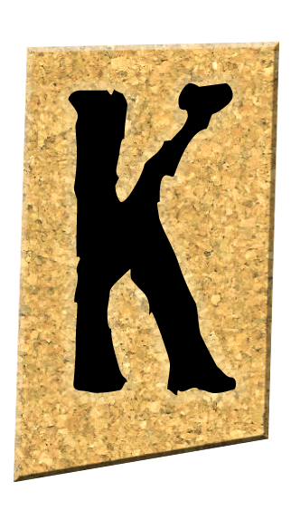
Assignment: Create a Digital Scrapbook using InDesign CS2 and Photoshop CS2.
Instructions: Create a digital scrapbook using different papers, fonts, embellishments, picture frames and layouts for each page.
Each section should have a minimum of 5 pages.
Each page should have should have a minimum of 1 digital picture and
2 scanned pictures. (May be changed with approval from teacher)
Design a front, back, and side for your binder.
Print each page out in black and white and show to teacher for approval to print in color!
Section 1: Through the Years
- Name
- Date of birth
- Birthplace/hospital
- Hometown
- Family
- Pets

Section 2: Much loved
- Favorite song
- Group
- Movie
- Foods
- Sports
- Cars
- Team

Section 3: Pastimes and Goings-on
- Fishing
- Hunting
- Water sports
- Football/basketball
- Golf
- Cheerleading
- Clubs

Section 4: Reminiscing
- Prom
- Friends
- Homecoming
- School trips
- Dances
- Senior pictures

Supplies needed: 2’ Binder with clear outside inserts. Package of clear page inserts.

Internet Resources: www.freedigitalscrapbooking.com, www.digitalscrapbooking-free.com, www.scrapbookflair.com, your research.
Suggested Steps:

- Decide on a layout
- Design/download your background paper
- Add photos
- Add photo mats or frames
- Add effects such as drop shadowing
- Create embellishments
- Add titles
- Add journaling

